**D3L Use Case**

Nick Bashor

Patrick Grzegorczyk

Wesam Jabali

Joey Navarro

Kevin Sass

Luigi Yebra

# **About this Document**

This document provides a background for creating use cases and a specific template for use case development.

# **Disclaimer**

Not all the contents are fully functioning. Some contents are either in progress or still up for debate.

# **Use Case Specification Template**

The next few pages with red text are intended to form the use case template – Copy them to a new document for each use case developed for the project.

## **Actors, Goals and Use Case Briefs**

|  |  |  |  |
| --- | --- | --- | --- |
| **Actors** | **Task-Level Goal** | **Priority** | **Brief** |
| **Students** | * Setup page | * Medium | * See the classes |
| **Faculty** | * Setup page | * Medium | * **Create course** * Can create teams among student |
| **Admin** | * Setup page | * Medium | * Give admin page power to add roles to whom had register * **Create course** |

## 

## **Use Case Diagram**

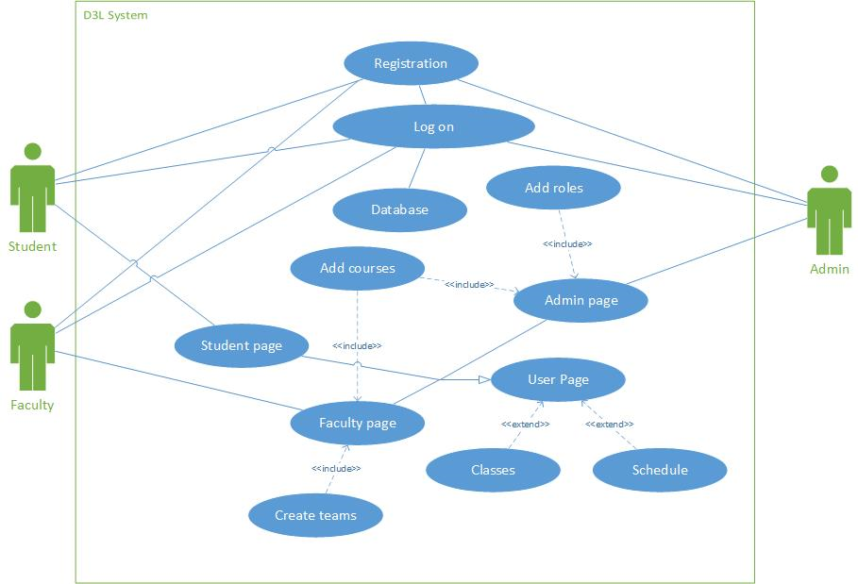

## ***Use Case Specifications***

|  |  |
| --- | --- |
| **Title** | Logging On |
| **Main Goal** | * To log in to a specific account |
| **Actors Involved** | * Students * Faculty * Admin |
| **Props** | * Database * Log on Page |
| **Action** | * Front end will communicate with Back end, and back end will verify if username and password are within the database. |
| **End State** | * Display either Student or faculty or Admin page |

|  |  |
| --- | --- |
| **Title** | Registration |
| **Main Goal** | * To create an account * Add it to database |
| **Actors Involved** | * Students * Faculty * Admin |
| **Props** | * Database * Registration Page |
| **Action** | * After the Registration page acquires the necessary information, It will pass the info to the backend and add to the database |
| **End State** | * Return to the Log on Page |

|  |  |
| --- | --- |
| **Title** | Admin Page |
| **Main Goal** | * Display the current students and faculty members * Set roles * Create Courses |
| **Actors Involved** | * Admin |
| **Props** | * Database * Admin page * Add course page |
| **Action** | * Front end will communicate with Back end, and back end will verify if user and password is within the database |
| **End State** | * Display admin page |

|  |  |
| --- | --- |
| **Title** | Student Page |
| **Main Goal** | * To see classes |
| **Actors Involved** | * Students |
| **Props** | * Database * Student page |
| **Action** | * Display student’s classes from database |
| **End State** | * Display student page |

|  |  |
| --- | --- |
| **Title** | Faculty Page |
| **Main Goal** | * Look at classes * Create courses * Create student teams |
| **Actors Involved** | * Faculty |
| **Props** | * Database * Faculty page * Add course page * Create team page |
| **Action** | * Gives the faculty member to view his or her classes * Faculty can create team based on student roster * Faculty can create a course |
| **End State** | * Display faculty page |